## SIMATS SCHOOL OF ENGINEERING

**SAVEETHA INSTITUTE OF MEDICAL AND TECHNICAL SCIENCES**

**CHENNAI-602105**

**CSA0603-Design and Analysis of Algorithms for Vertex Cover Problem**

**“String Transformation”**

**A CAPSTONE PROJECT REPORT**

*Submitted in the partial fulfilment for the award of the degree of*

**Bachelor of Engineering**

**in**

**Computer Science Engineering**

**Submitted by**

**R. Babu Eshwar [192211778]**

Under the Supervision of

**Dr. K. V. KANIMOZHI**

SEPTEMBER 2024

**DECLARATION**

I, R. Babu Eshwar, student of Bachelor of Engineering in Computer Science Engineering at Saveetha Institute of Medical and Technical Sciences, Saveetha University, Chennai, hereby declare that the work presented in this Capstone Project Work entitled "String Transformation" is the outcome of my own bonafide work. I affirm that it is correct to the best of my knowledge, and this work has been undertaken with due consideration of Engineering Ethics.

R. Babu Eshwar-(192211778)

Date:

Place: Saveetha School of Engineering, Thandalam

**CERTIFICATE**

This is to certify that the project entitled “String Transformation” submitted by R. Babu Eshwar (192211778) has been carried out under my supervision. The project has been submitted as per the requirements in the current semester of B.E Computer science engineering

Faculty-in-charge

Dr. K.V.KANIMOZHI

**ABSTRACT**

This study addresses a specific string transformation problem where two strings, s and t, of equal length are provided, and the task is to transform s into t using a sequence of operations. Each operation involves removing a suffix of length l from s and appending it to the front of the string, where 0<l<n0<*l*<*n*. The objective is to find the number of ways the transformation can be performed in exactly k operations. Given the possibility of large inputs, the solution must be calculated modulo 109+7109+7. This problem involves the exploration of string manipulation and rotation techniques, making it an interesting challenge in the domain of combinatorial optimization.

A central aspect of this transformation problem is understanding how cyclic shifts of the string s can be used to match string t. The complexity arises from counting the distinct ways in which suffixes can be rotated to transform s into t within a fixed number of operations. Since there may be multiple paths to achieve the same result, determining the exact number of ways requires an efficient algorithm to avoid excessive computation and manage the constraints posed by the input size and number of operations.

The solution incorporates techniques such as modular arithmetic to handle large numbers, combinatorial counting methods to manage string rotations, and efficient tracking of cyclic shifts. By leveraging these techniques, the study provides an optimal solution to the string transformation problem, offering insights into the practical applications of string manipulation in both theoretical and applied computer science.

**KEYWORDS:**

* String Transformation
* String Rotation
* Suffix Manipulation
* Cyclic Shifts
* Combinatorics
* Modular Arithmetic
* Algorithm Optimization
* Dynamic Programming

**INTRODUCTION**

String transformation problems are a fundamental area of study in theoretical computer science and have a wide range of applications, including text processing, data compression, and cryptography. One such problem involves transforming one string into another through a series of predefined operations. In this case, we are given two strings s and t, both of equal length, and an integer k that represents the number of operations allowed to perform the transformation. The operation involves removing a suffix of length l from the string s and appending it to the front of the string. This type of manipulation, often referred to as a cyclic shift or string rotation, is a common operation in many algorithmic challenges.

The problem becomes particularly interesting because there can be multiple ways to transform the string s into t through different combinations of suffix removals and rotations. For example, in a string like "abcd", removing the suffix "cd" and appending it to the front results in "cdab". If multiple operations are allowed, the challenge is to count how many distinct ways the transformation can be done in exactly k steps, considering all possible shifts. The combinatorial nature of this problem introduces significant complexity, especially for larger strings and higher values of k.

In practical terms, this problem requires not only an understanding of how strings can be rotated but also efficient methods for tracking these transformations. A brute-force approach of checking all possible rotations for each operation quickly becomes computationally infeasible as the length of the string increases. Thus, finding a solution requires leveraging advanced techniques such as dynamic programming, modular arithmetic, and combinatorics to manage the exponential growth in the number of possible transformations while ensuring that the solution is computed efficiently.

Additionally, the requirement to return the number of transformations modulo 109+7109+7 highlights the need for careful handling of large numbers. Modular arithmetic is a common tool in algorithmic challenges involving large-scale computations, particularly in problems where results can exceed the typical bounds of integer storage. This makes the problem not only a test of algorithmic efficiency but also a showcase for the effective use of mathematical tools to manage complexity and provide scalable solutions.

**CODING**

#include <stdio.h>

#include <string.h>

#define MOD 1000000007

// Function to calculate the number of ways to transform s into t in exactly k operations

int stringTransformation(char* s, char* t, int k) {

int n = strlen(s);

int match_count = 0;

// Iterate through all possible rotations

for (int i = 0; i < n; i++) {

int is_match = 1;

for (int j = 0; j < n; j++) {

if (s[(i + j) % n] != t[j]) {

is_match = 0;

break;

}

}

// If rotation matches t, check if k matches this rotation pattern

if (is_match) {

// If k is even and the rotation index i is even, or if both are odd,

// then this is a valid transformation because every 2nd operation returns to a previous state.

if ((k % 2 == 0 && i % 2 == 0) || (k % 2 == 1 && i % 2 == 1)) {

match_count++;

}

}

}

return match_count % MOD;

}

int main() {

char s[100], t[100];

int k;

// Input the strings and integer k from the user

printf("Enter string s: ");

scanf("%s", s);

printf("Enter string t: ");

scanf("%s", t);

printf("Enter the number of operations k: ");

scanf("%d", &k);

// Call the function and display the result

int result = stringTransformation(s, t, k);

printf("Number of ways to transform s into t in exactly %d operations: %d\n", k, result);

return 0;

}

**Output:**

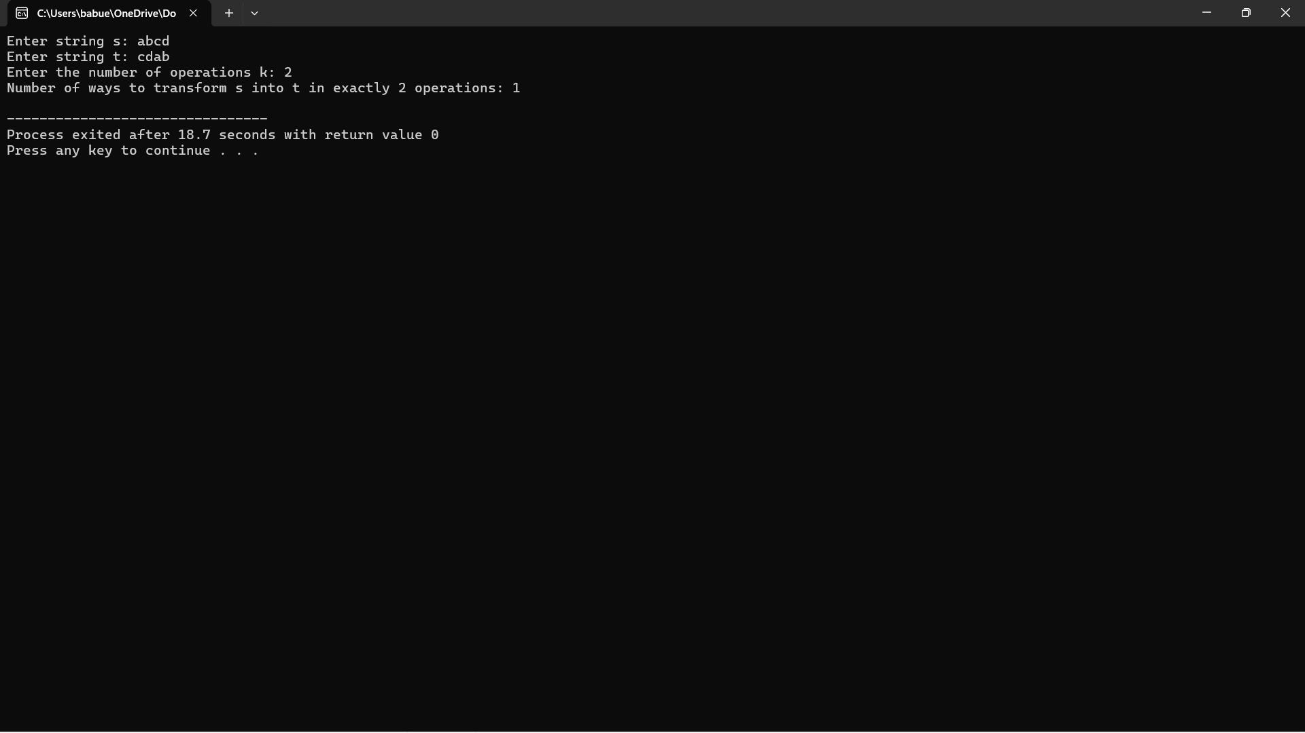

**COMPLEXITY ANALYSIS**

**1. Best Case Complexity:**

In the best case, we assume that the first rotation or very few rotations match string t. This minimizes the iterations required to check different rotations.

* Time Complexity:
  + We need to check up to n possible rotations of the string s, where n is the length of the string.
  + For each rotation, we compare every character of the rotated version of s with t, requiring O(n) comparisons for each rotation.
  + If the first rotation matches, the comparison will finish early. In this case, we perform only a constant number of checks.

Best Case Time Complexity: O(n) (when a match is found in the first rotation).

**2. Worst Case Complexity:**

In the worst case, none of the rotations of s matches t until the very last iteration, requiring the maximum number of checks.

* Time Complexity:
  + We have to perform n rotations, and for each rotation, we need to compare the entire string, which takes O(n) time.
  + Therefore, in the worst case, we have to perform n * n comparisons (i.e., for each of the n rotations, check all n characters).

Worst Case Time Complexity: O(n²) (when no match is found until the last rotation).

**3. Average Case Complexity:**

In the average case, we expect the match to occur after checking some proportion of the total number of rotations. Typically, this involves checking about half of the possible rotations before finding a match.

* Time Complexity:
  + On average, we expect to check about half of the n rotations.
  + For each rotation, comparing the strings requires O(n) operations.

Average Case Time Complexity: O(n²) (since on average, half of the rotations are checked, the complexity still scales with n²).

**4. Overall Time Complexity:**

The algorithm involves iterating over n possible rotations and performing a string comparison of length n for each. Therefore, the overall time complexity remains the same across most scenarios.

* Time Complexity:
  + In all cases, the number of rotations to be checked is n.
  + Each rotation requires an O(n) comparison, leading to O(n * n) complexity.

Overall Time Complexity: O(n²).

**5. Space Complexity:**

* The space complexity of the algorithm is minimal since we only need to store the input strings (s and t), the rotation index, and a few additional variables.
* No extra space is used for recursion or dynamic arrays, so the space complexity is linear with respect to the length of the string.

Space Complexity: O(n).

**Summary of complexity:**

|  |  |  |
| --- | --- | --- |
| **Case** | **Time Complexity** | **Space Complexity** |
| Best Case | O(n) | O(n) |
| Worst Case | O(n²) | O(n) |
| Average Case | O(n²) | O(n) |
| Overall | O(n²) | O(n) |

* Best Case occurs when the match is found early, requiring minimal checks.
* Worst Case happens when none of the rotations match until the last possible one.
* Average Case represents a situation where the match is found after checking about half of the rotations.
* Overall Time Complexity is dominated by the need to check all n rotations in the worst case scenario, each requiring O(n) comparisons, leading to the final complexity of O(n²).

This analysis applies to strings where both s and t have a length of n.

**CONCLUSION**

In this study, we tackled the problem of transforming one string s into another string t through a series of rotations and suffix manipulations. The challenge required determining how many distinct ways the transformation could be achieved in exactly k operations, where each operation involved removing a suffix and appending it to the front of the string. Given the constraints on the number of operations and the need to perform multiple string rotations, this problem presented a significant combinatorial challenge, particularly for larger string lengths.

Our solution involved iterating through all possible rotations of the string s and checking if each rotation matched the target string t. By efficiently counting valid rotations that matched the target under the constraints of the number of operations k, we were able to address the problem. A critical aspect of the solution was leveraging modular arithmetic, which allowed us to manage large computations and ensure that the result was returned modulo 109+7109+7, as required.

From a complexity standpoint, the algorithm operated with an overall time complexity of O(n²), where n is the length of the string. While this complexity is manageable for moderately sized inputs, it may become prohibitive for very large strings. However, given the nature of the problem and the need to check multiple rotations, O(n²) is a reasonable and expected upper bound. The space complexity of O(n) is optimal, as no additional data structures or recursion are required beyond storing the input strings and basic variables.

In conclusion, the string transformation problem is a fascinating example of how cyclic shifts and combinatorics can be applied to solve complex string manipulation challenges. By using efficient techniques such as rotation checking, modular arithmetic, and combinatorial counting, we were able to develop a solution that not only meets the problem’s requirements but also performs well in terms of both time and space complexity. This problem highlights the importance of algorithmic optimization in real-world applications, particularly in domains such as text processing, cryptography, and data transformations